Generative Design | Peter Byrne | CA1

The idea behind this project was to experiment with Perlin Noise to populate a blank pixel array using specific colour schemes. The canvas would fill with vibrant blends of different colours to represent the aesthetic capabilities using p5.js in generative design. The program is built using several of the theoretical generative design methods that we have learned about this year so far.

## Step 01

The program is setup with canvas size, pixel density and black background. This black background will be the blank pixel array that will be populated with the different colours blending together. A reset function is also included to reset the canvas to clear any existing colours that may be added so the program is essentially restarted.

## Step 02

To initiate the spread of colour throughout the screen, the program will use some initial colours to use to fill the rest of the screen. I started by drawing a triangular shape with three different colours for each side. This is drawn using beginShape() and endShape(). The generative design CDN libraries are also linked in the HTML index file. I will use this to save PNG snapshots of the output on screen and to measure results.

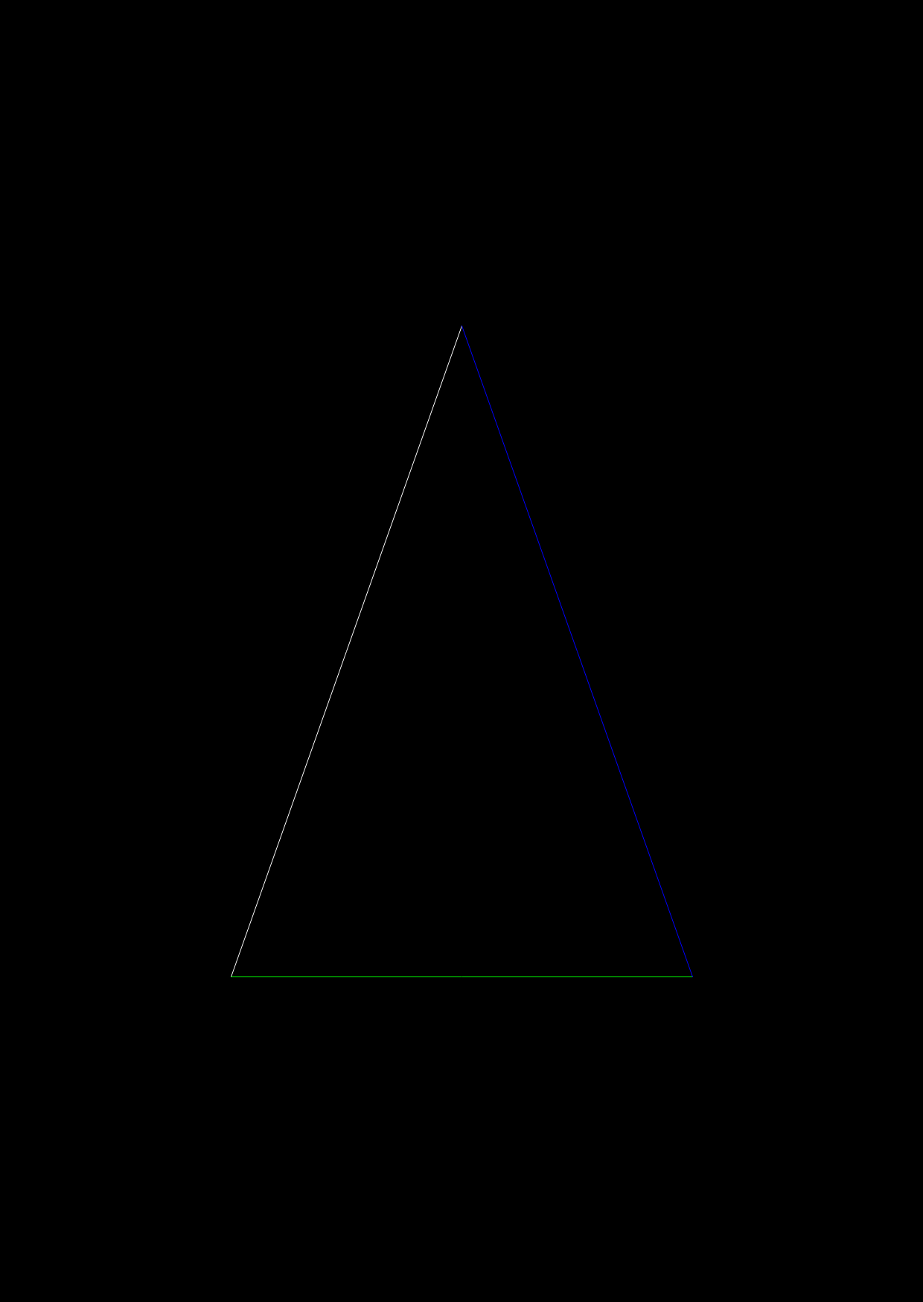

Figure 1 - Step02

# Step03

The program is built to then generate different shapes to increase the number of colours that will spread throughout the canvas, e.g. triangle, 3 colours, square 4, colours. As the user presses the number on the keyboard e.g. ‘4’, a square will be drawn on screen.

# Step04

The spreading of colour works on each draw, a large number of random pixels are selected using random(), if one of those pixels is selected that has some colour in it. i.e. where one of the shapes has been drawn, then the program checks to see if the next pixel to it is also coloured or black. If the next pixel is black, then it will be filled with colour. As the canvas size is large at 1240x1748, a large number of pixels will have to be chosen each time. I set this number to 100000. Then, to ensure randomness, the second pixel chosen can be up, down, left or right from the original coloured pixel. I use a loop to choose this random direction.

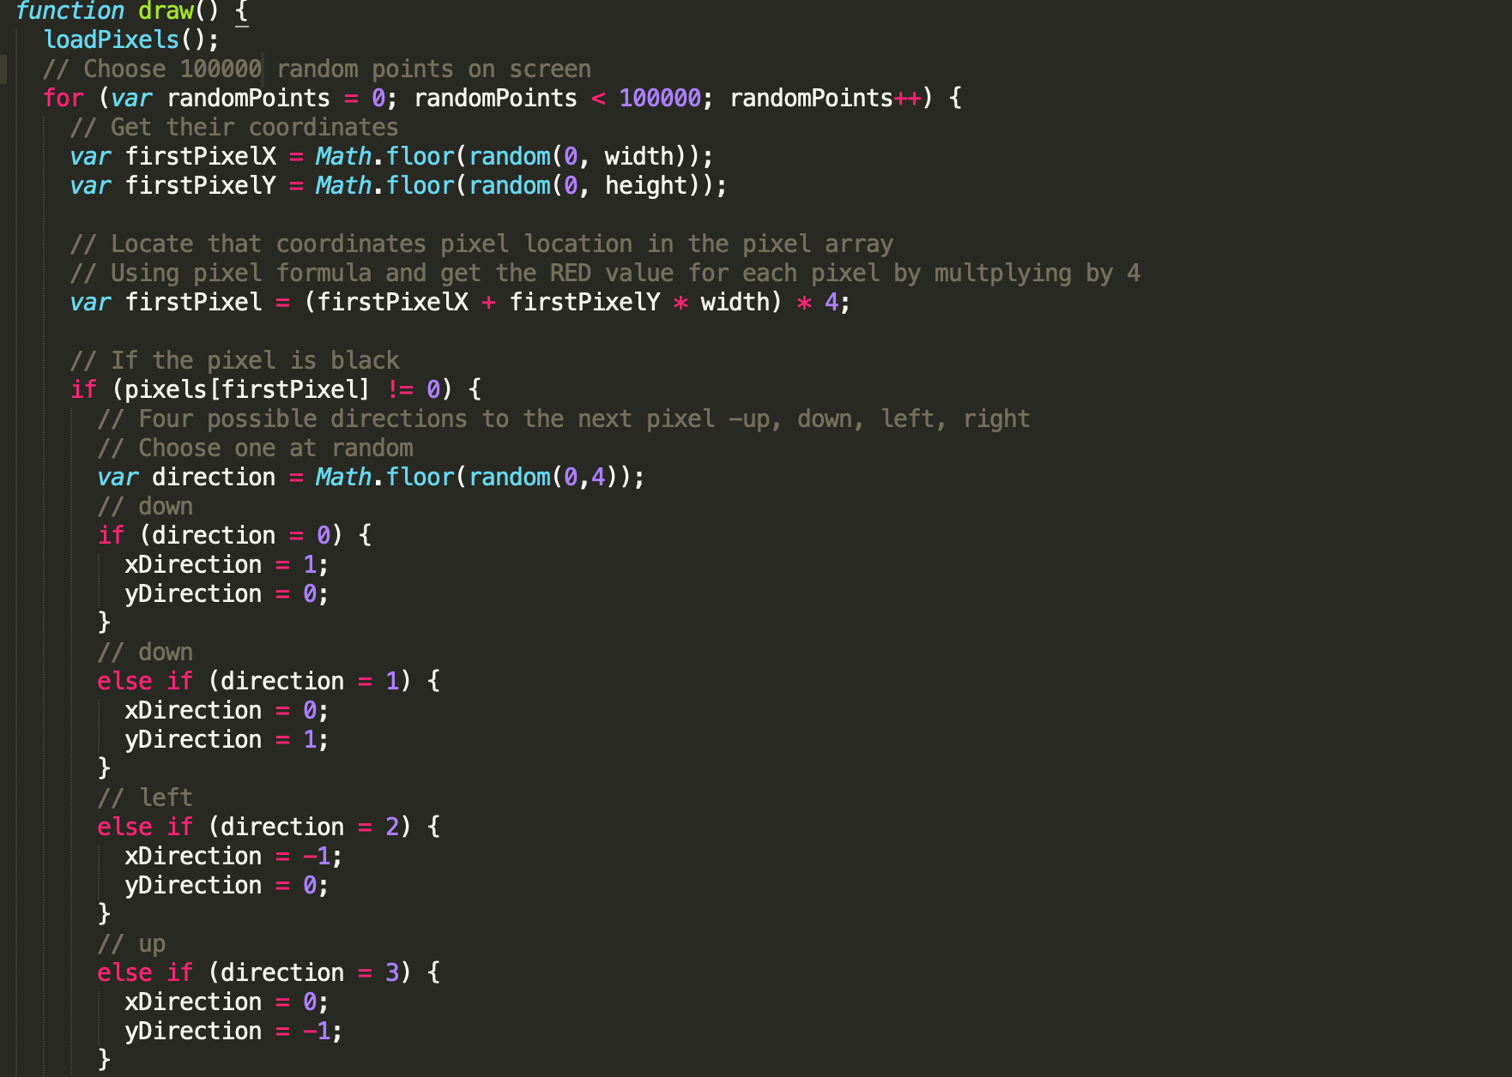

Figure 2 - Random points and random direction

# Step05

A simple mechanism locates the pixel RGB values for that pixel in the pixel array.

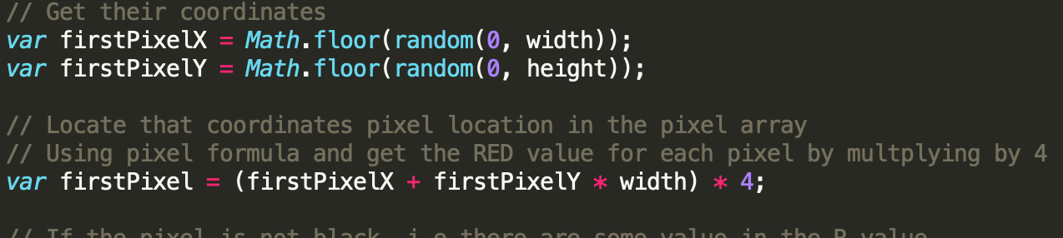

Figure 3 - Get pixel array coordinates

To colour the blank second pixel, you locate it within the pixel array like the first pixel, and then set its RGB colour values. This is the method of how the entire canvas will be filled with colour.

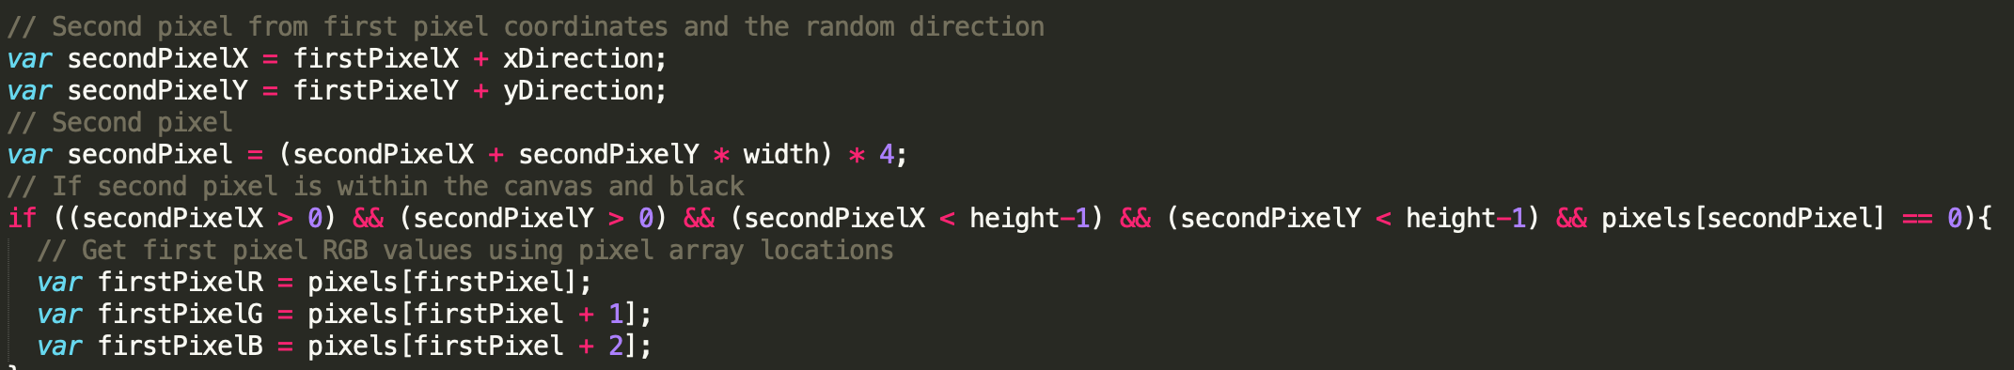

Figure 4 - set second pixel RGB values

# Step06

To implement noise, the first pixel’s RGB values are used as values in noise, they are then mapped between -30 and 30 which is the range in which the RGB values of the next pixel will increase or decrease. This number of 30 is to ensure that there are not vast differences in colours between one pixel and the next.

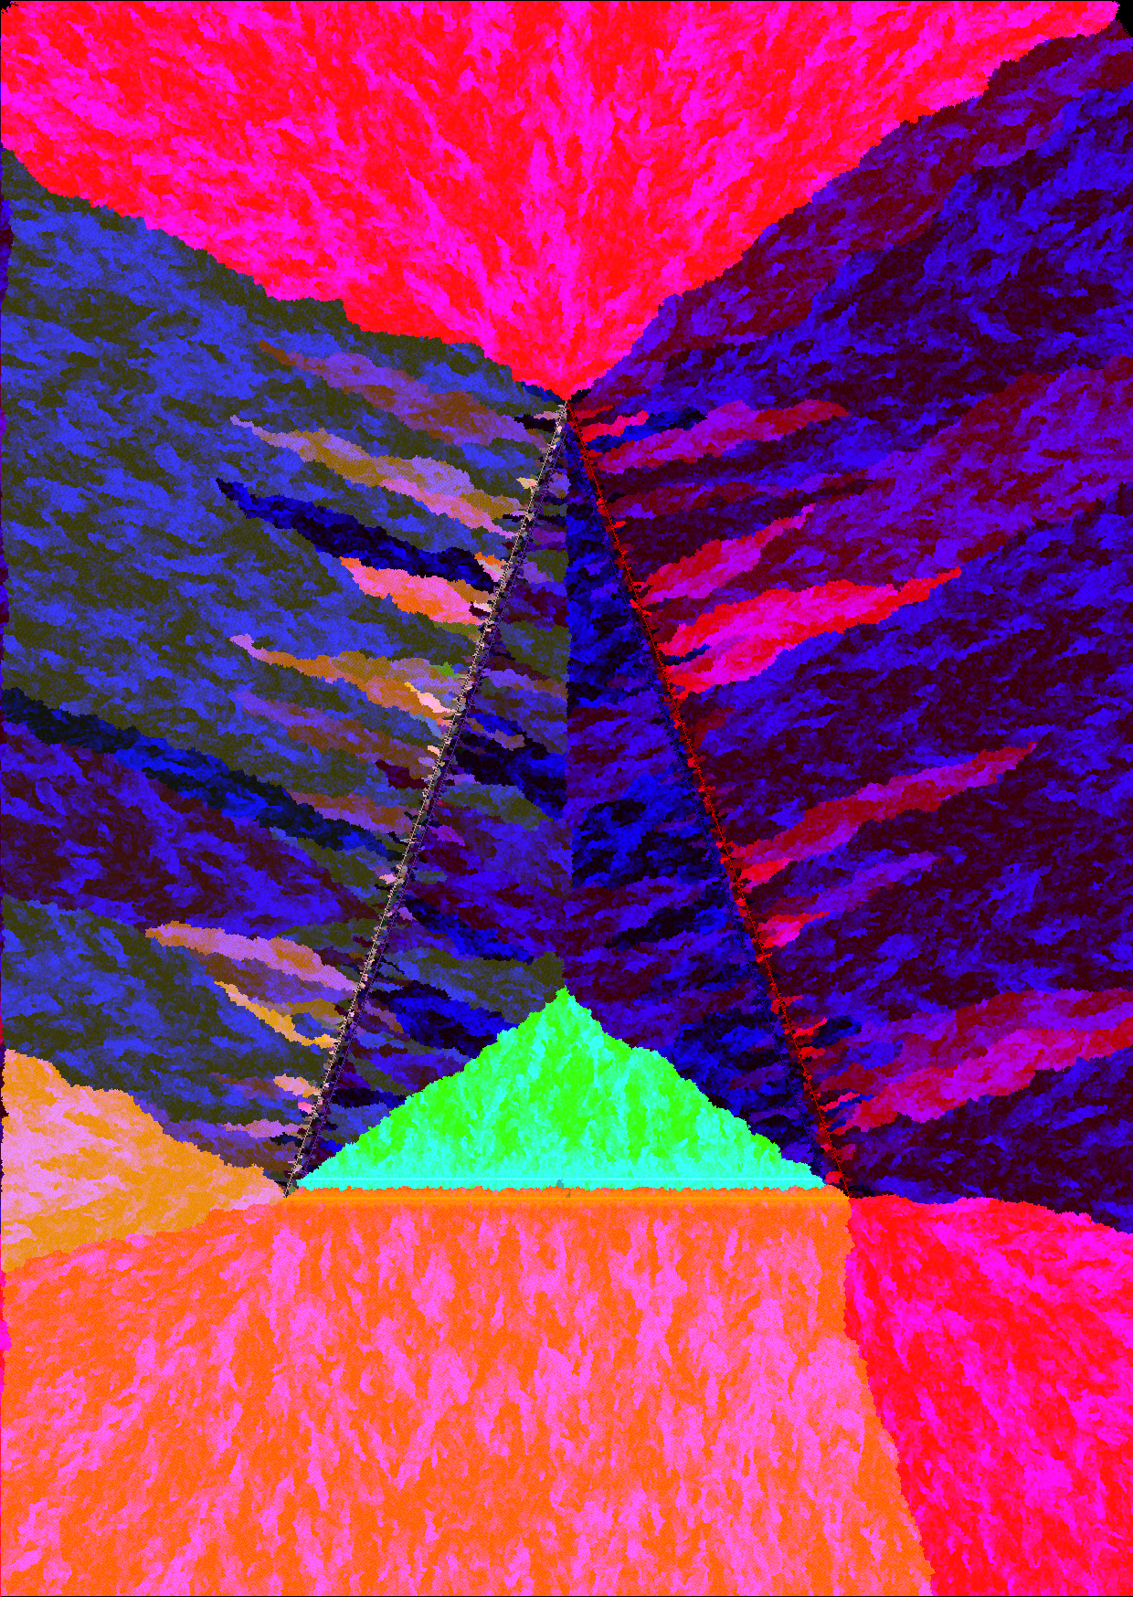

Figure 5 - Colour blends using noise

# Step07

As you can see above, the shapes produce nice colours but there is no real basis to this design other than a triangle in the centre of the screen. I decided to switch the design to a series of circular patterns. These circles would surround two letters ‘GD’ to represent generative design and the letters would appear to be spreading or leaking colours to fill the canvas.

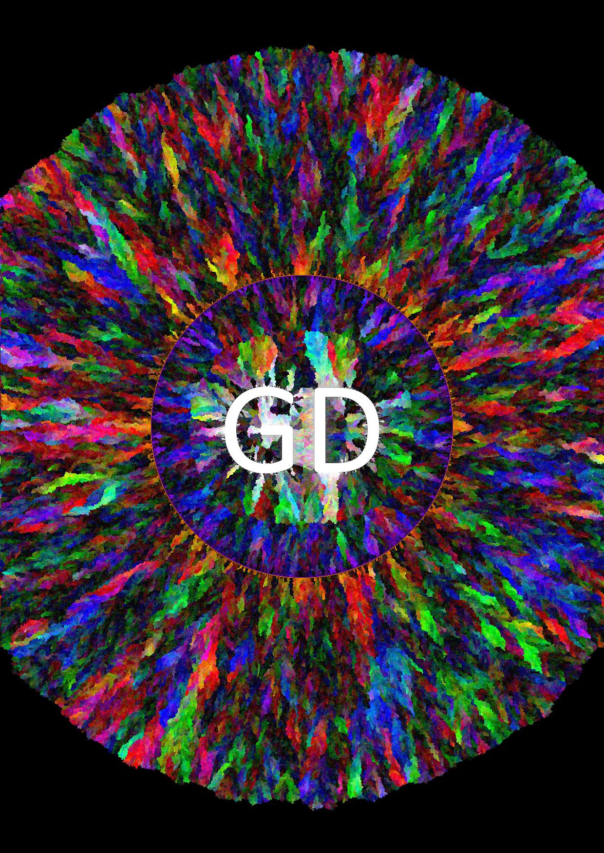

Figure 6 – Random blends and text

# Step08

Then, to make some connections between the colours being bled throughout the page, the circles surrounding the letters in the centre of the page would be randomly generated but using triadic colours – so each colour is triadically spaced around the colour wheel. I built this building my own triadic colour generator by just swapping out RGB values to reflect the previous colour’s triadic equivalent. Then the circles on the outside of the letters in each corner of the canvas are tetradic, meaning they are on four equal points on the colour wheel. These are generated using a plugin named colour-scheme.js. The program is now a visual representative of how triadic and tetradic colours blend together. The user can refresh these colours by clicking their mouse.

